PERSONAL INFORMATION | Vinko Krstanović
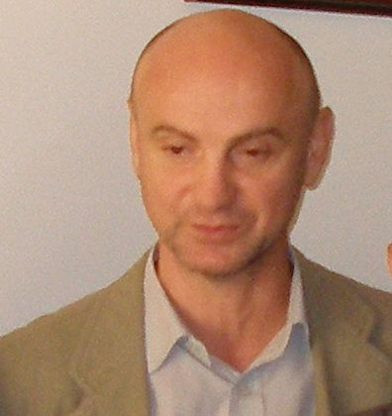 |   Vijenac Ivana Meštrovića 96, Osijek, 31000, Hrvatska

098 99 53 422

vinko.krstanovic@ptfos.hr
http://www.ptfos.unios.hr/index.php/zaposlenici/38-zaposlenici/nastavno-osoblje/292-vinko-

krstanovic
 | Sex Male | Date of birth 18/10/1964 | Nationality Croatian

WORK EXPERIENCE

Date of last academic advancement | 25.02.2016. - Full Professor
Date of last academic advancement | 2010-2016 Associate Professor; Assistant Professor; 1996-2005 Assistant;
Name and address of employer  Type of business or sector | University in Osijek, Faculty of Food Technology, Franje Kuhača 20, 31000 Osijek, Croatia
Name and address of employer  Type of business or sector | Science and higher education

EDUCATION AND TRAINING

2004.  2000.  1995. | PhD in Biotechnical sciences, Biotechnology, University in Zagreb, Faculty of Food Technology and Biotechnology  Msc. in Biotechnical sciences, Biotechnology, University in Zagreb, Faculty of Food Technology and Biotechnology  Dip. ing. of food technology, University in Osijek, Faculty of Food Technology

PERSONAL SKILLS

Mother tongue | Croatian
Other language(s) | UNDERSTANDING |  | SPEAKING |  | WRITING
Other language(s) | Listening | Reading | Spoken interaction | Spoken production
English | B1 | B1 | B2 | B1 | B1

Organisational / managerial skills | - Head of Department of Bioprocess Engineering 2008 -2014

Job-related skills

Computer skills | - Good command of Microsoft Office™ tools

Driving licence | - B

ADDITIONAL INFORMATION

Leader of the national scientific projects:
1. Improvement of food safety in production and processing of cereals (2007-2013)

Associate in national scientific projects:

Professional projects:
- Research of malting procedures for domestic wheat varieties: leader Srećko Tomas;

Publications: | http://bib.irb.hr/lista-radova?autor=235062&period=2007  https://scholar.google.com/scholar?hl=en&as_sdt=0%2C5&q=Vinko+Krstanovi%C4%87&btnG=  https://www.researchgate.net/profile/Vinko Krstanovic3

